**AWS CLOUD COMPUTING**

**CODING CONTEST – I**

**727721EUIT055**

**M.IMAYESH**

**Q1:**

1.

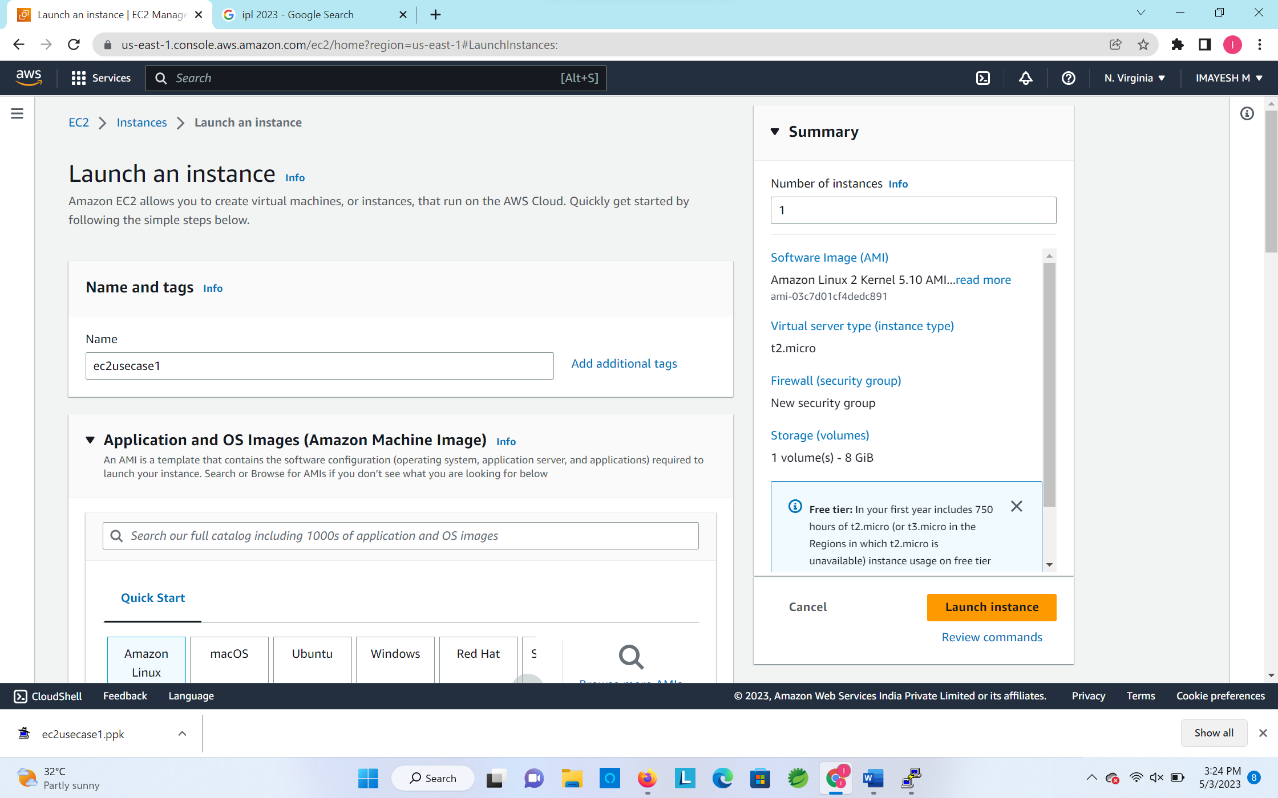

2.

3,4.

Creation of EC2 Instance:

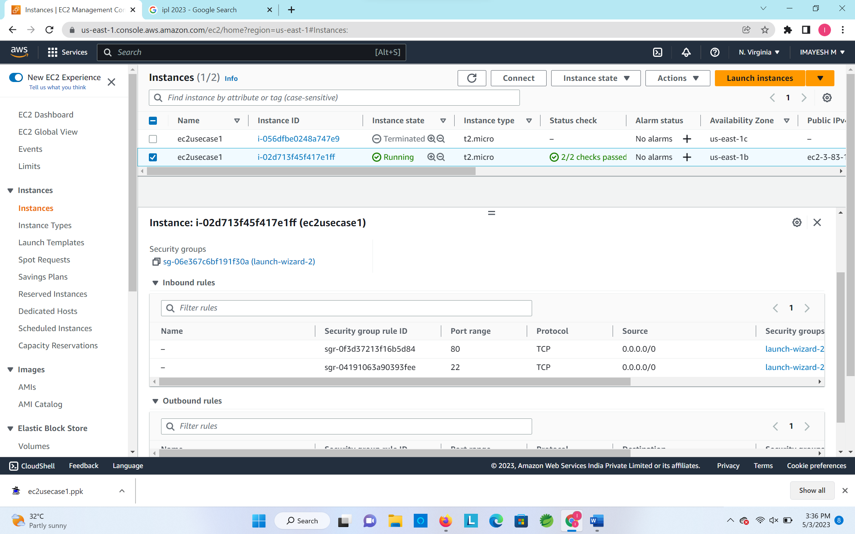

**Q2:**

1.

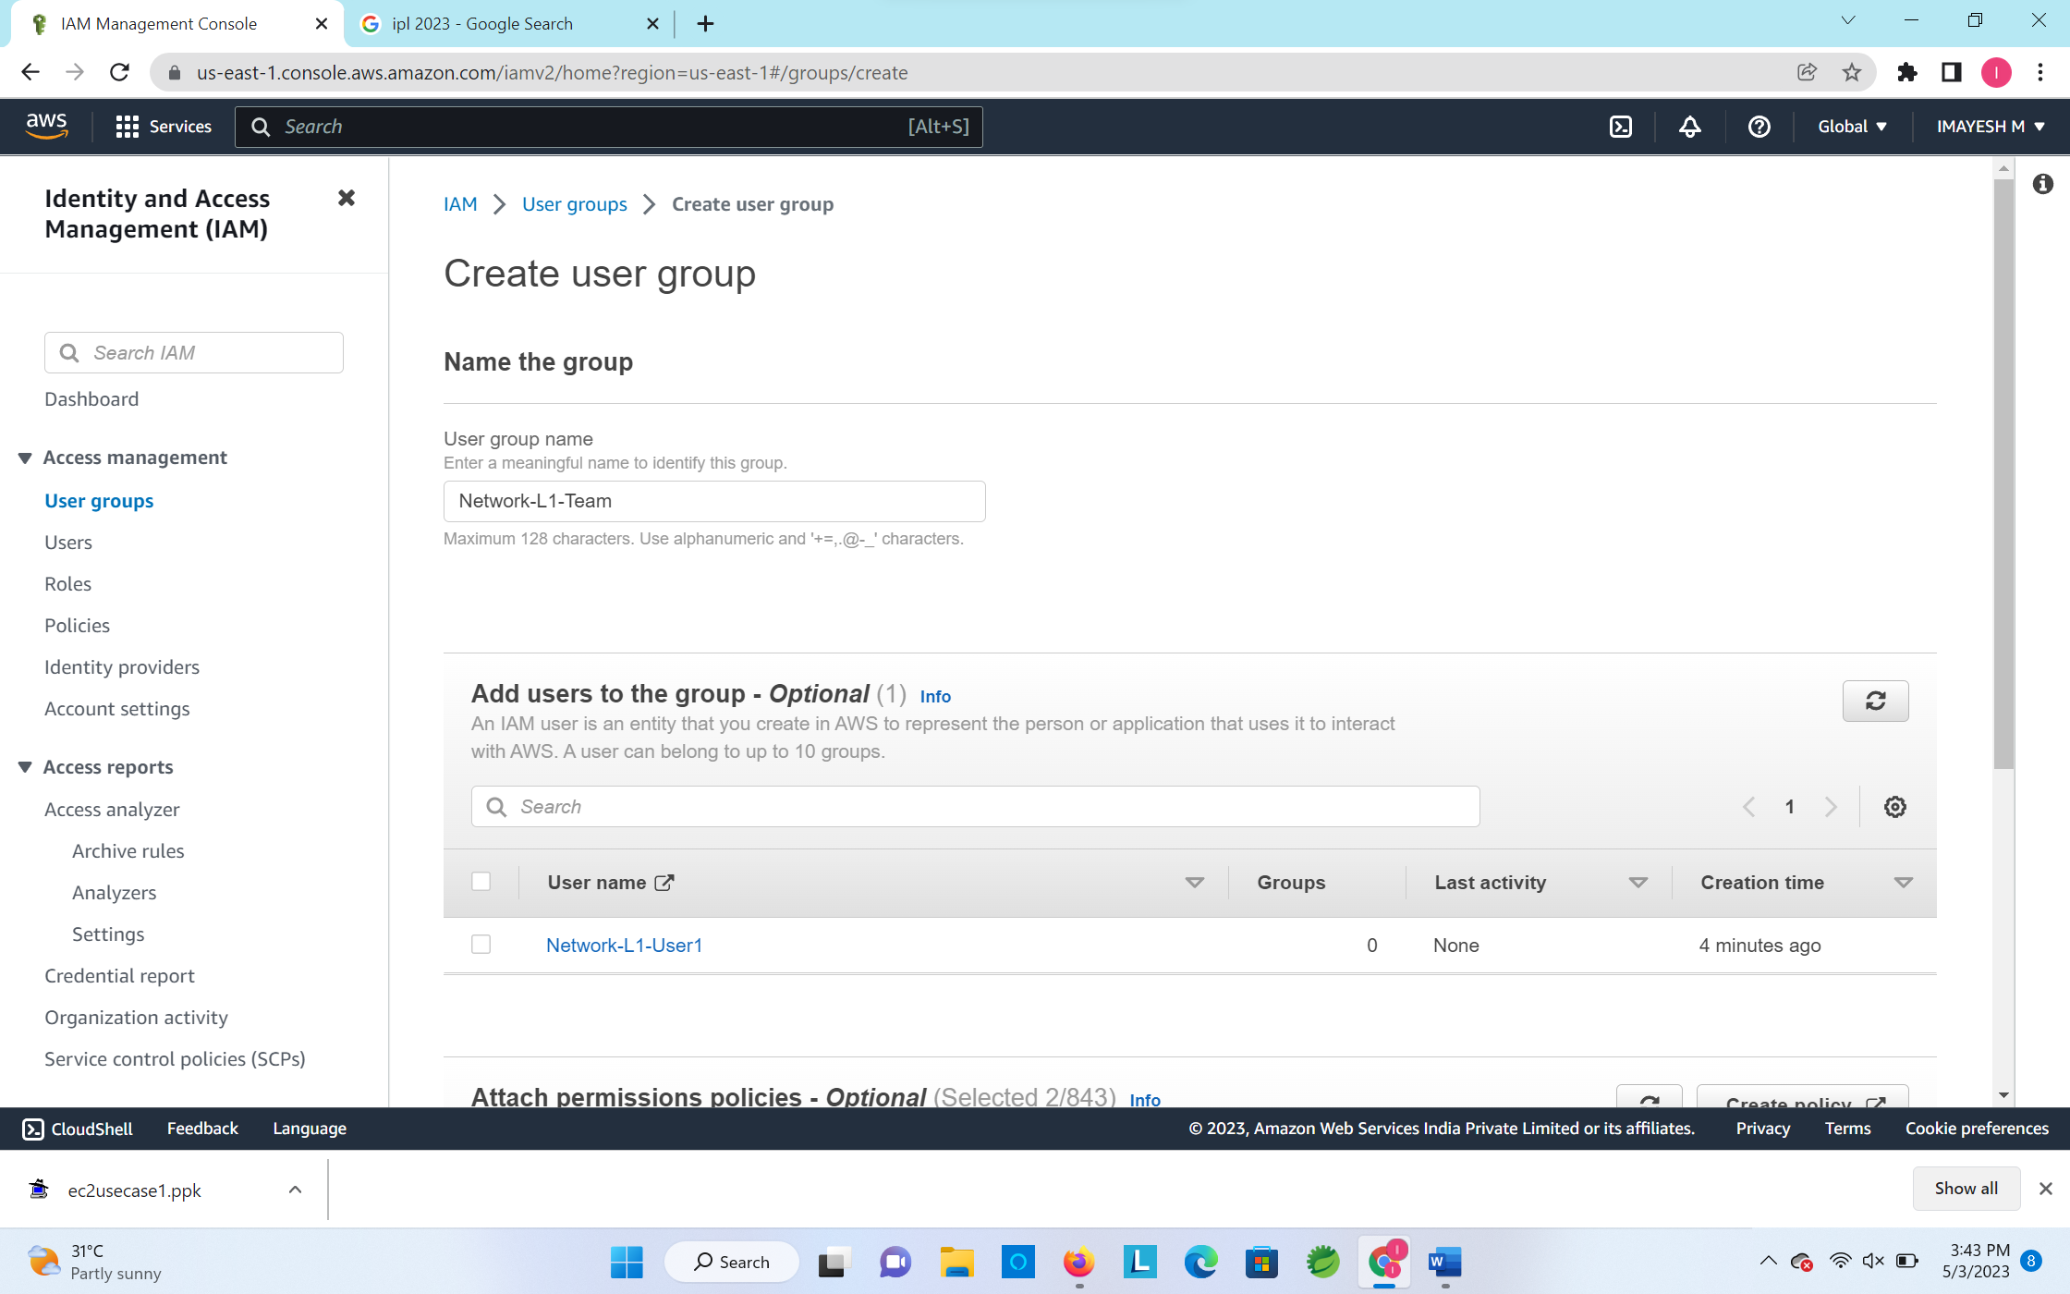

2.

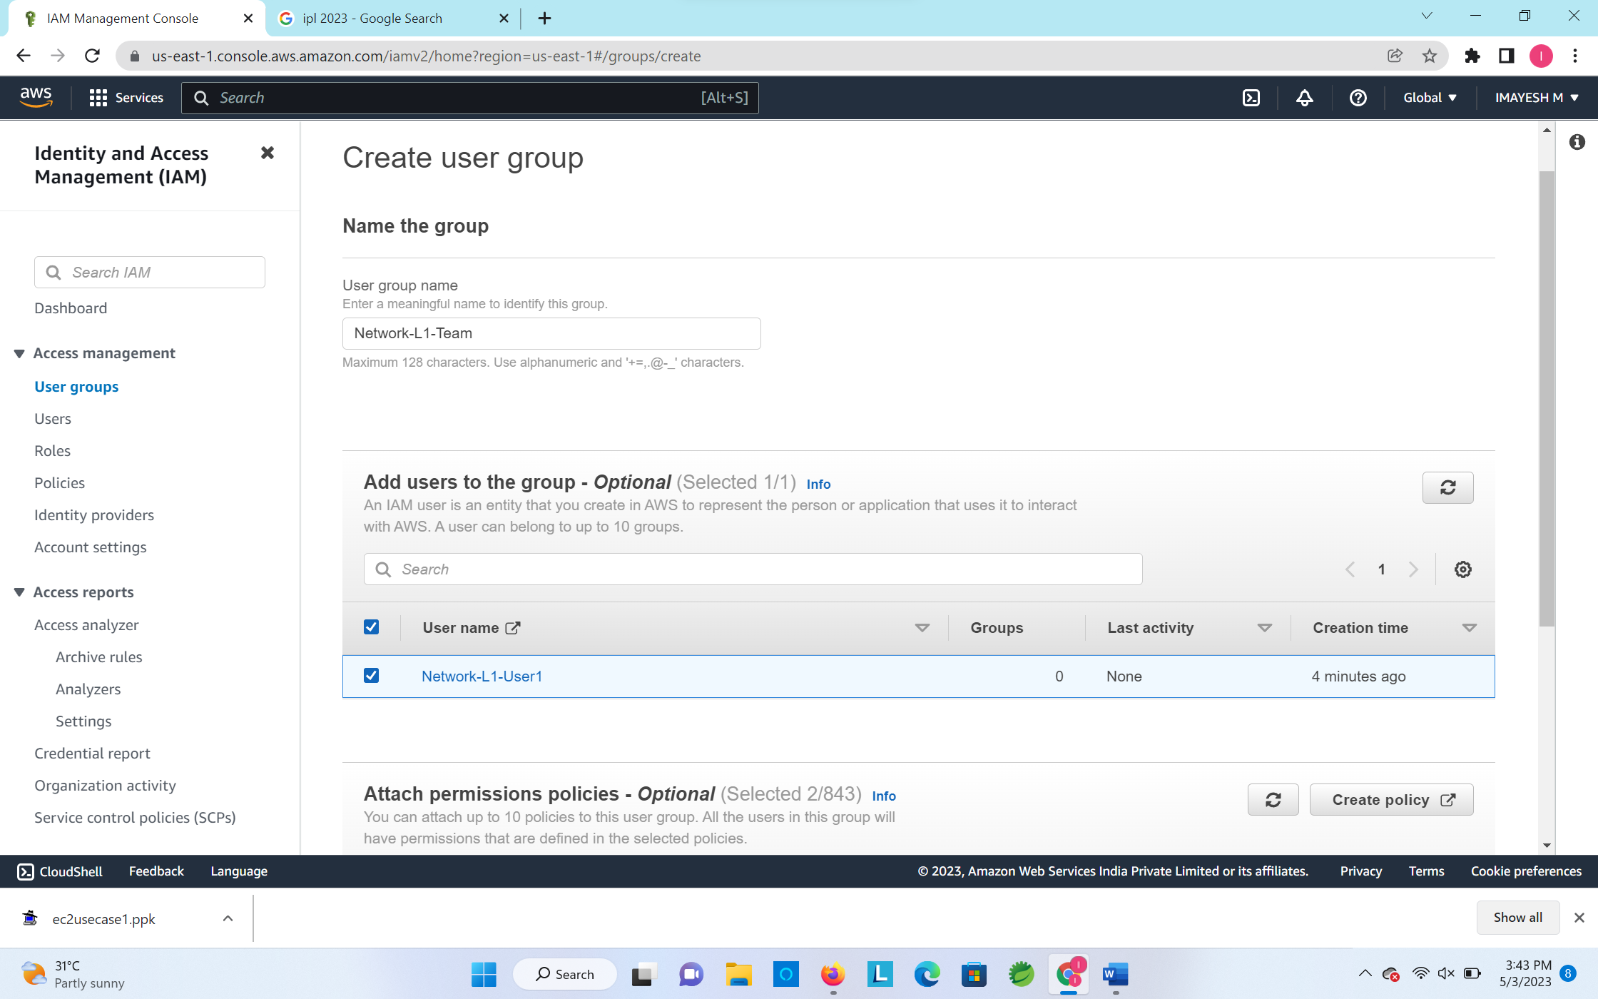

3.

4.

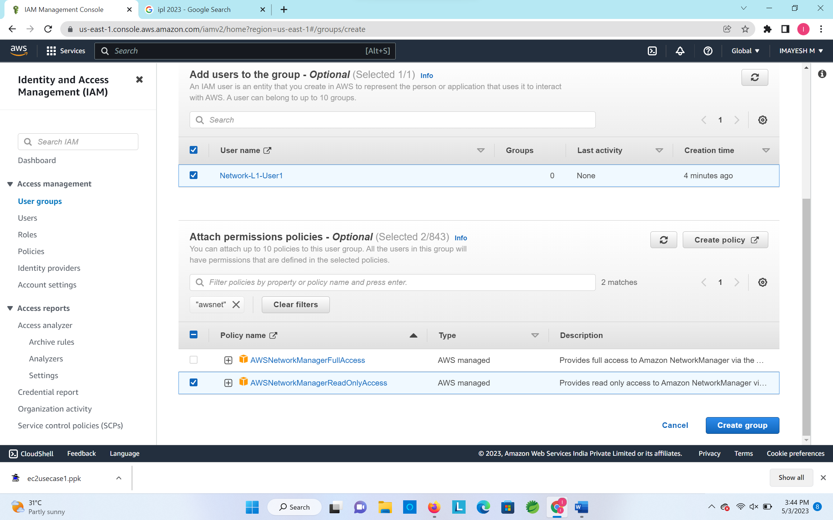

Creation of User:

Creation of User Groups:

**Q3:**

1.

2.

Creation of S3 bucket:

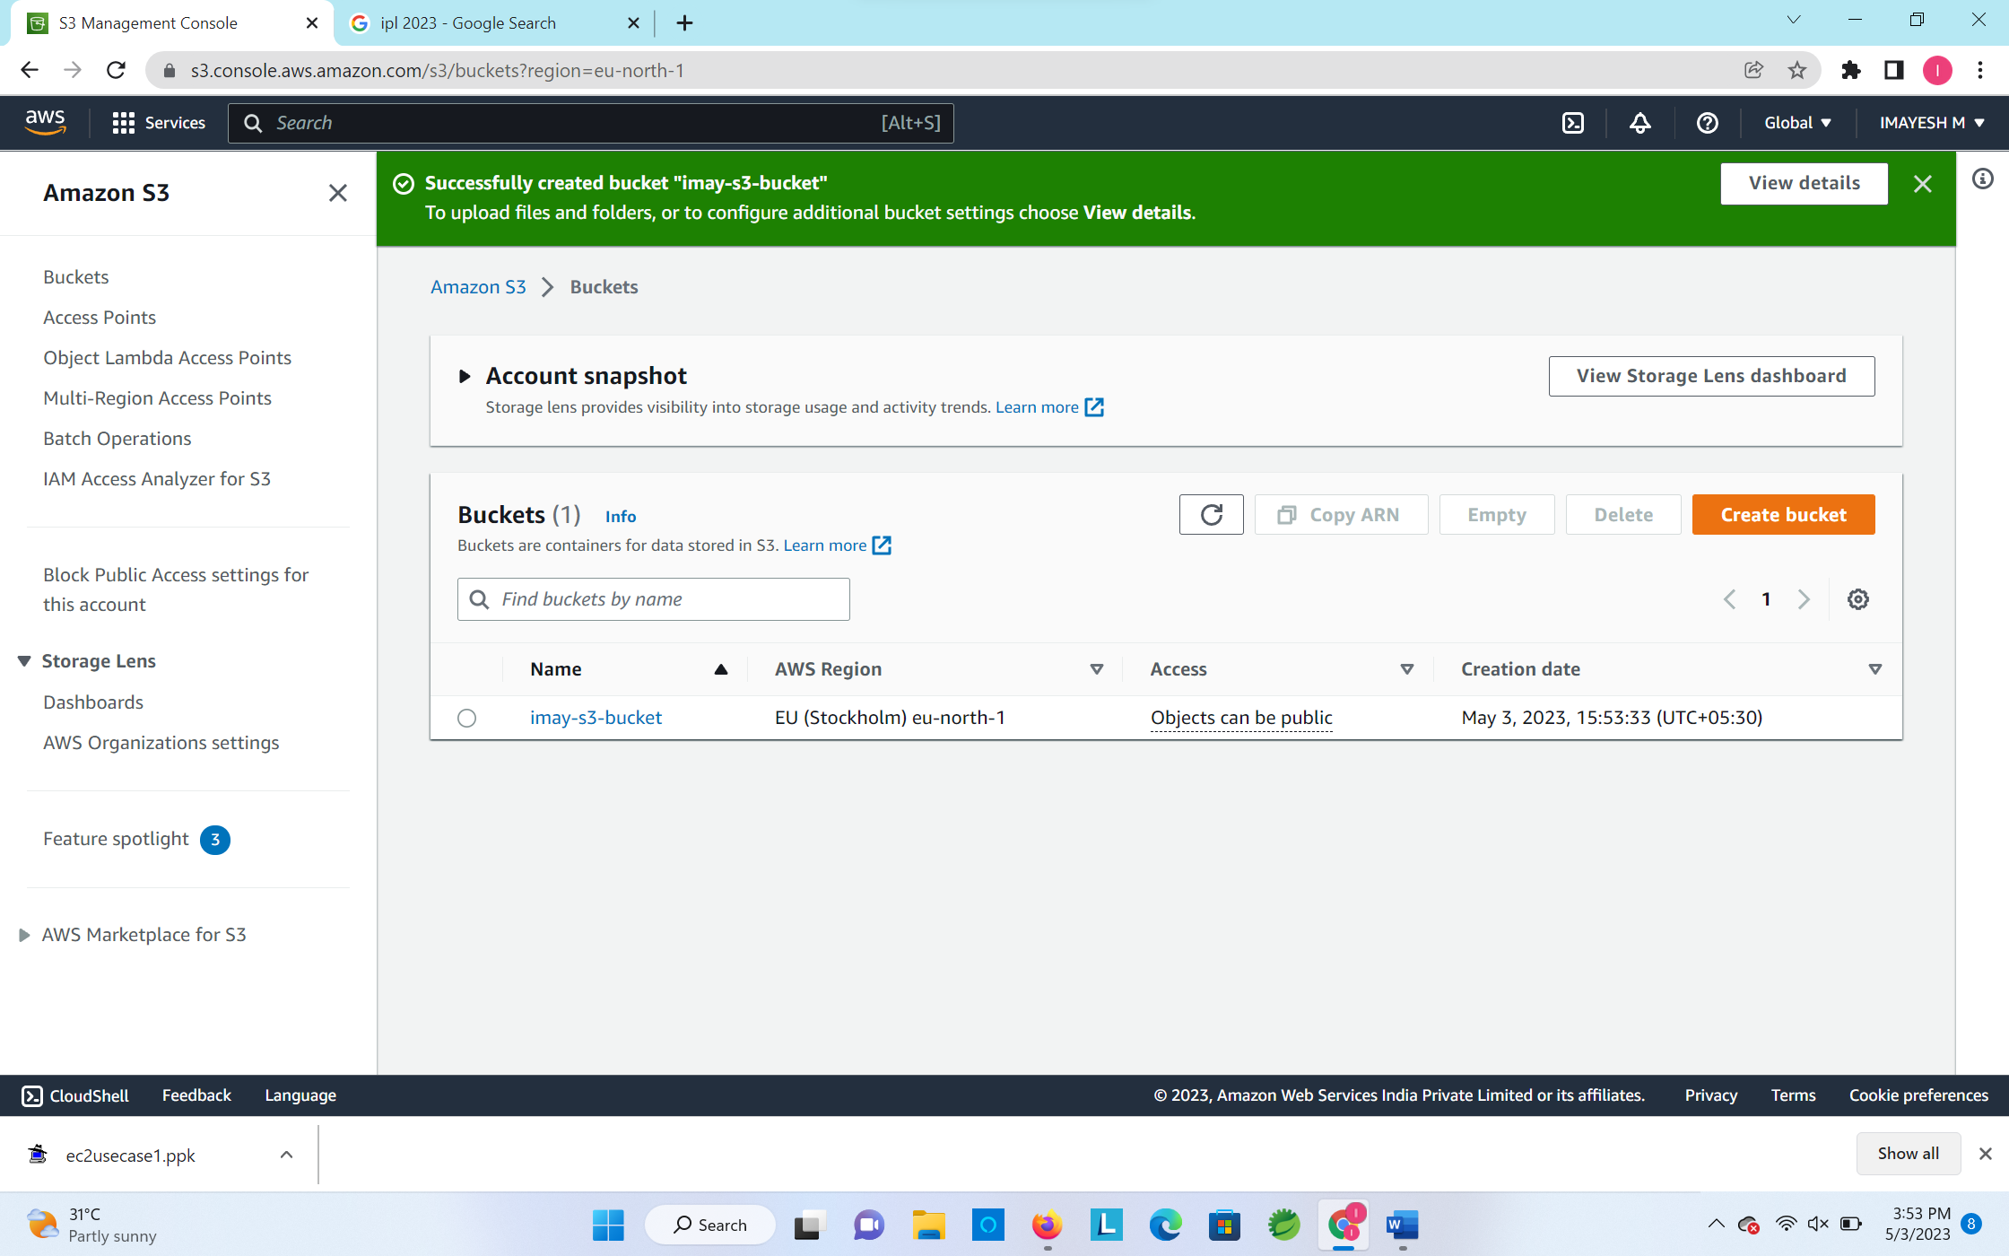

3.

4.

Accounts.txt (publicly accessible):

